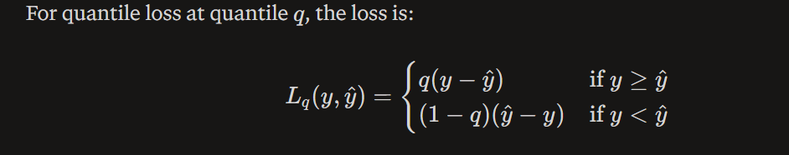
This means the model is not trying to learn the mean. It is trying to learn a specific percentile.
- If q=0.5, it learns the median.
- If q=0.9, it learns a high forecast so that only about 10% of true values fall above it.
- If q=0.1, it learns a low forecast.
y-hat is the predicted value
y is the actual value
- Basically, loss function will be calculated differently for the 3 quantiles i.e., 0.1, 0.5, and 0.9
- Suppose y = 150 and y-hat is 70, then according to the above formula loss will be
q(y – y-hat) which will be –
- q(0.1) = 8
- q(0.5) = 40
- q(0.9) = 72
- As can be noticed from the above calculation, q(0.9) is the highest loss because it is being penalized the most, because it is underestimating.
- Suppose, y = 20 and y-hat = 60, then according to the above formula loss will be
(1-q)*(y – y-hat) which will be –
- q(0.1) = 36
- q(0.5) = 20
- q(0.9) = 4
- As can be noticed from the above calculation, q(0.1) is the highest loss because it is being penalized the most, because it is overestimating
- So in a nutshell, quantile loss produces different levels of forecast which in the language of business would mean, being pessimistic or optimistic about the forecast.

